**Guide to Querying Data from Sources in Chat**



## 

## **Introduction**

In this guide, we will learn how to perform data querying from sources through the chat. We will understand how to connect the documents from which we want the user to receive information in the chat.

In the Sources tab, we need to select the document/documents or folder from which we want the user to receive information.

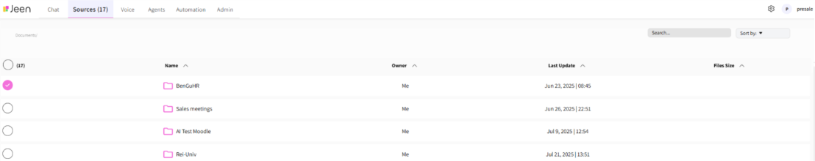

After that, when we move to the Chat tab and ask a question, the chat will answer the question based on the document we selected. In other words, the documents selected in the Sources tab will serve as the information infrastructure on which the question-asking process will be performed.

